**Name: Omkar pralhad Gharat.**

**Enrollment No.: 2101950**

**Cloud Computing Practical-2**

**\*\*\*\*\*\*\*\*\*\*\*\*\*\*\*\*\*\*\*\*\*\*\*\*\*\*\*\*\*\*\*\*\*\*\*\*\*\*\*\*\*\*\*\*\*\*\*\*\*\*\*\***

**Launch EC2 Instance (Linux)- AWS Platform.**

**\*\*\*\*\*\*\*\*\*\*\*\*\*\*\*\*\*\*\*\*\*\*\*\*\*\*\*\*\*\*\*\*\*\*\*\*\*\*\*\*\*\*\*\*\*\*\*\*\*\*\*\***

**Step-1:** **Login into AWS student Login**

**Click on module -> Select Learner Lab -> Click on AWS with indicated green light**

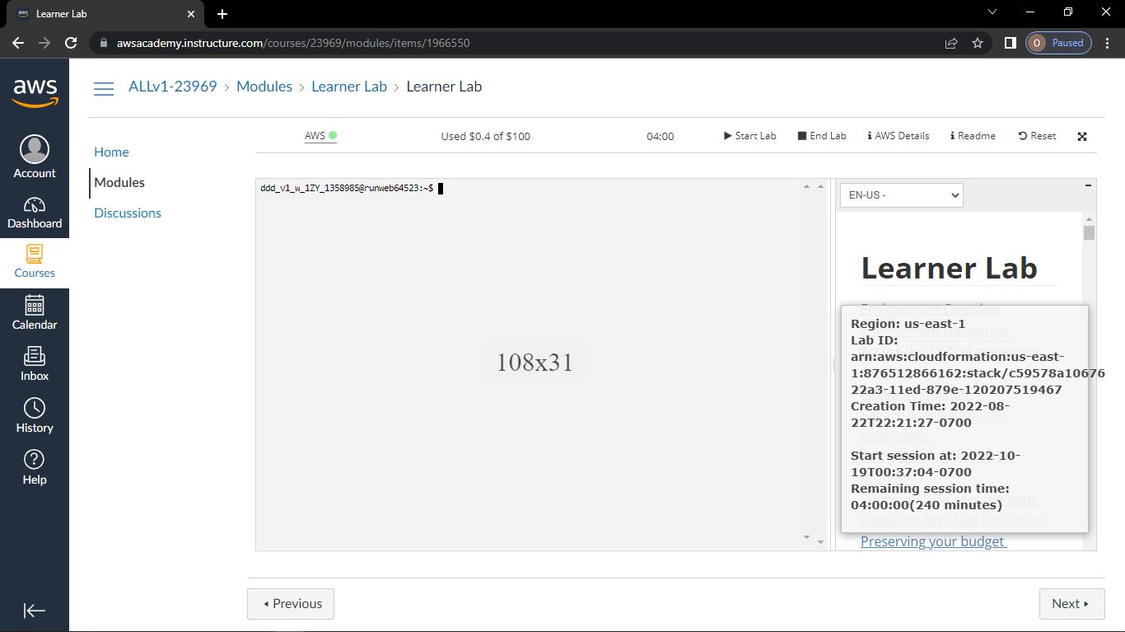

**Step-2: Go to Services -> Below that select Compute-> EC2**

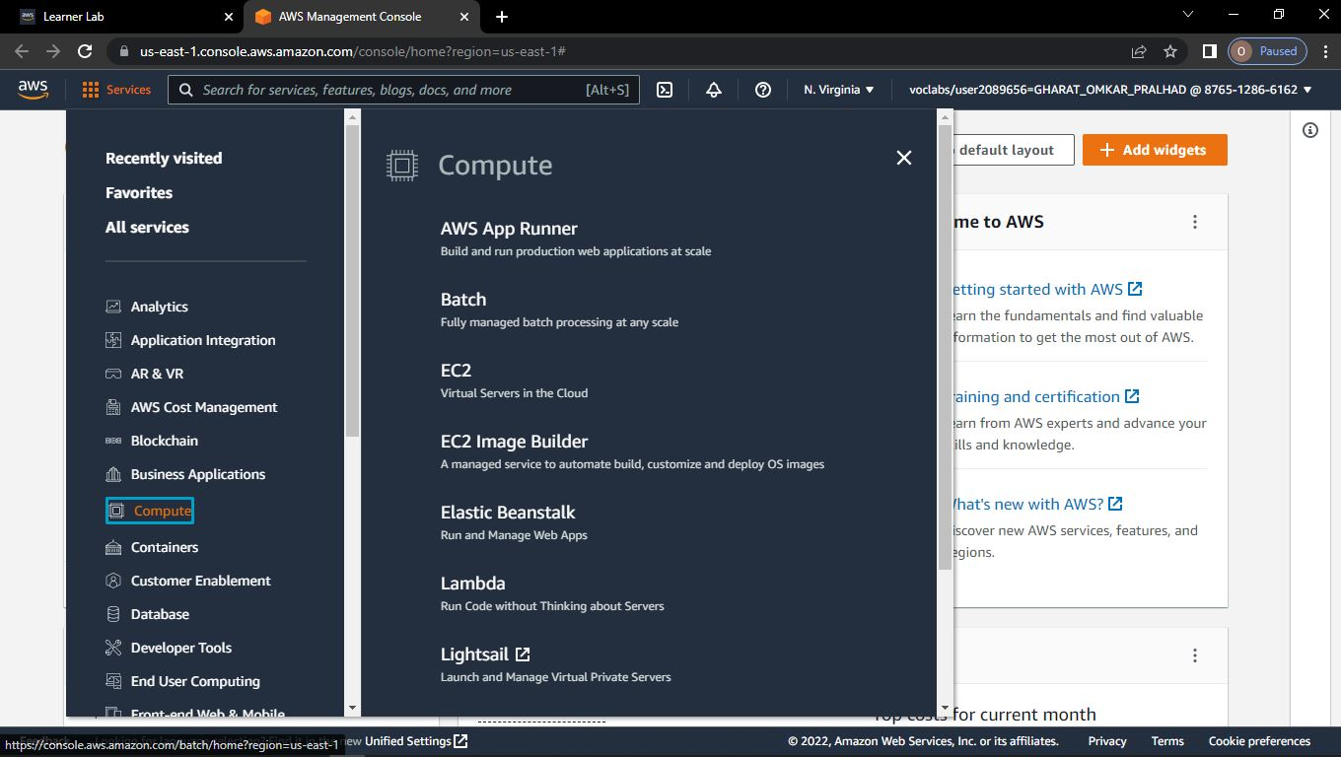

**Step-3: Click on EC2**

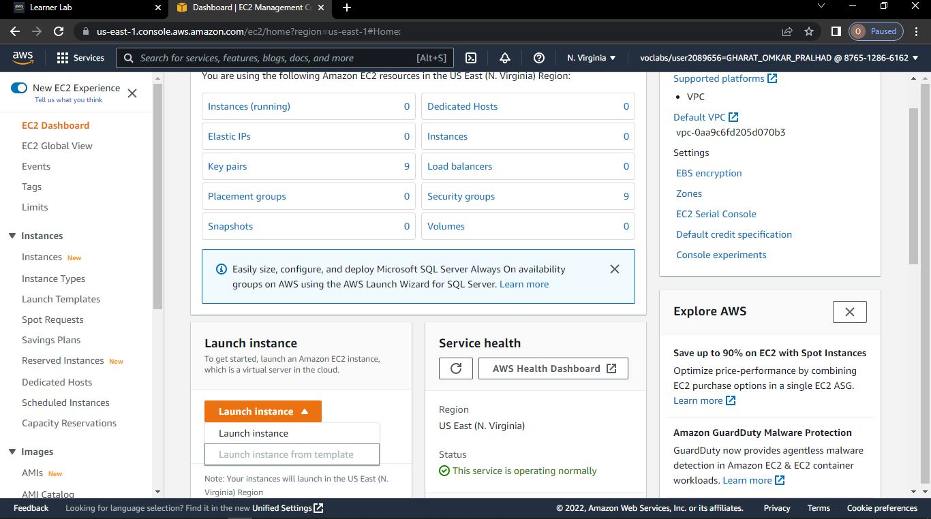

**Step-4: Click on launch instance**

**>Give any name of instance**

**>Give any name of key pair**

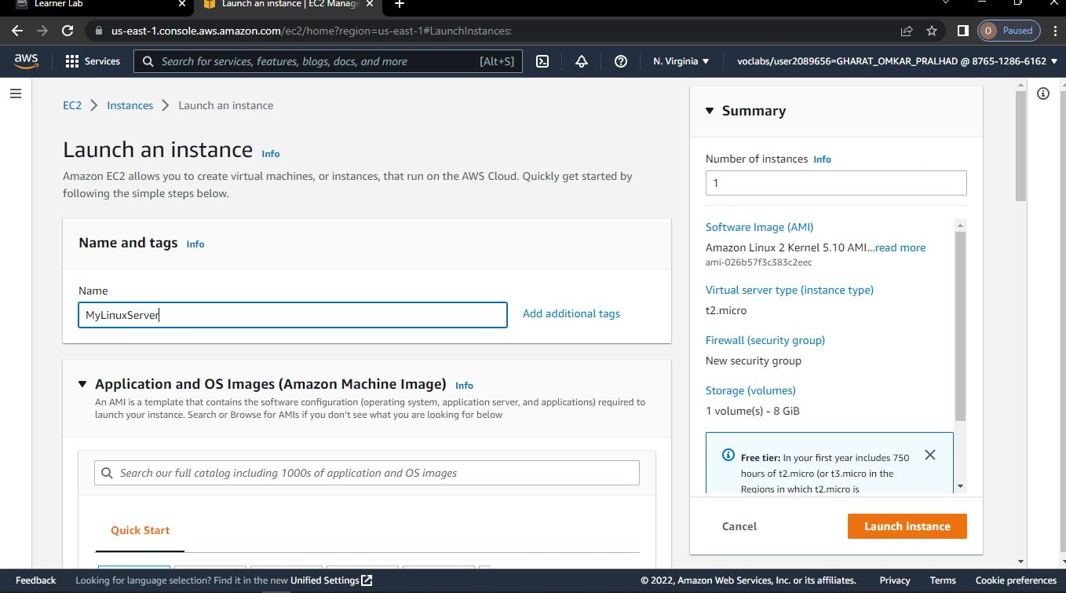

**Step-5: Click on create key pair**

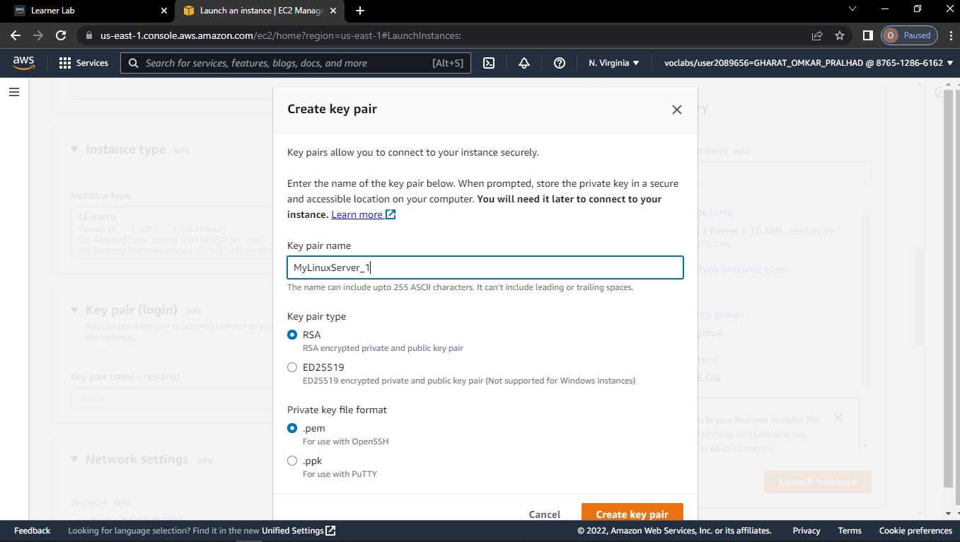

**Step-6: Click on launch instance**

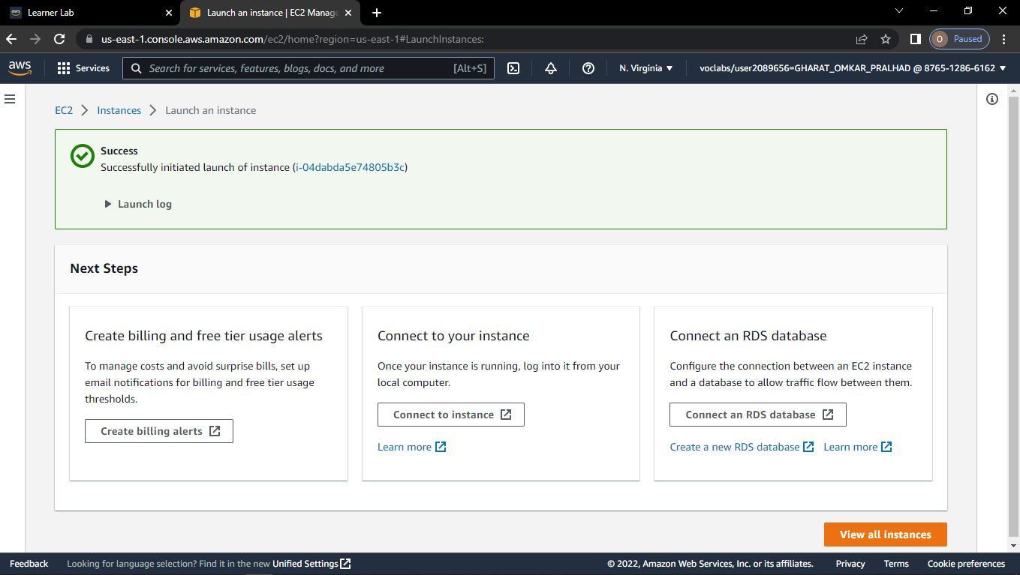 **Step-7: Click on view all instances**

**->Instance State will start Running**

**->Copy the IP address**

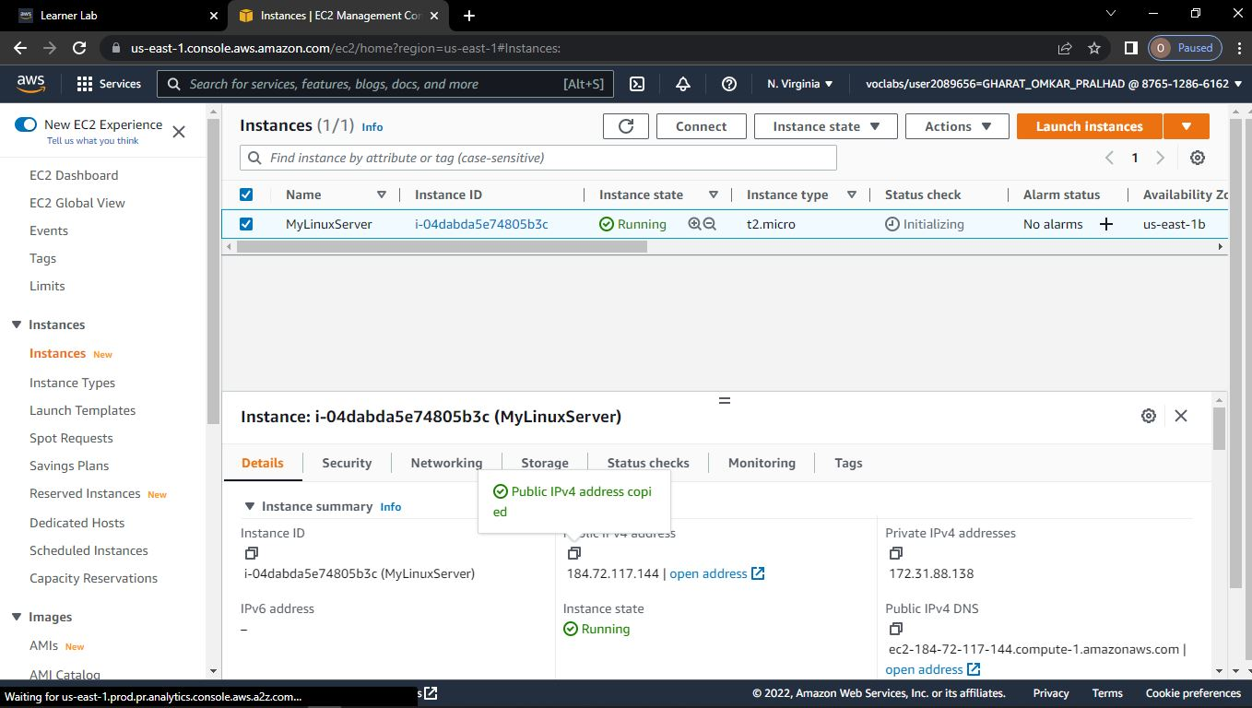



**Step-8: Go to Puttygen🡪Click on Load**

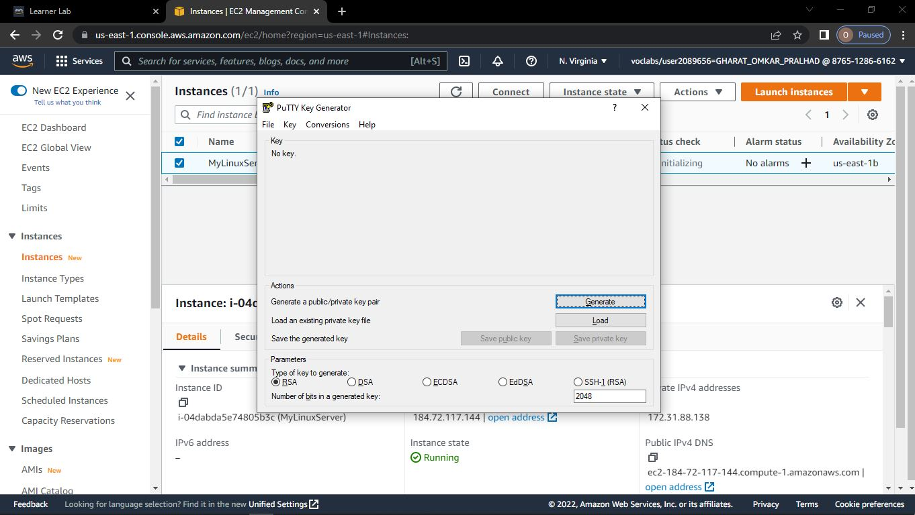



**Step-9: Open the pem file**

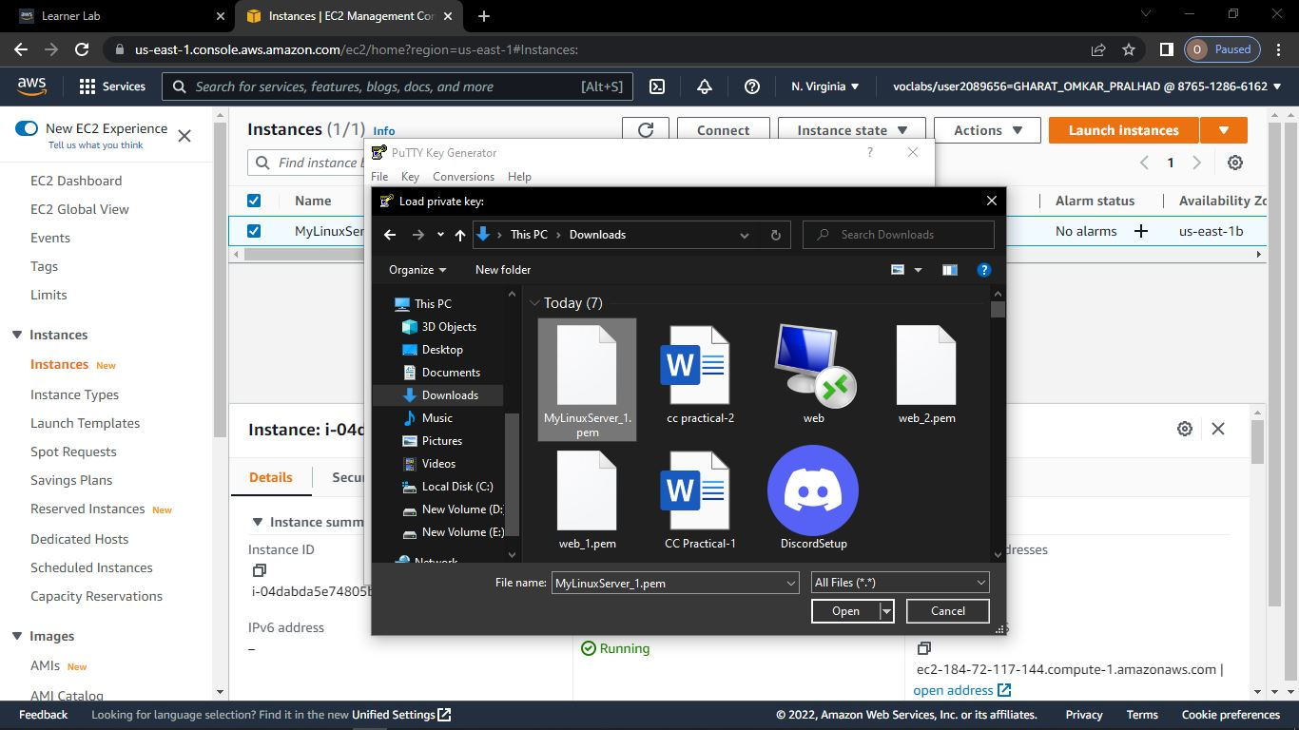

**Step-10: Click on Save Private Key**

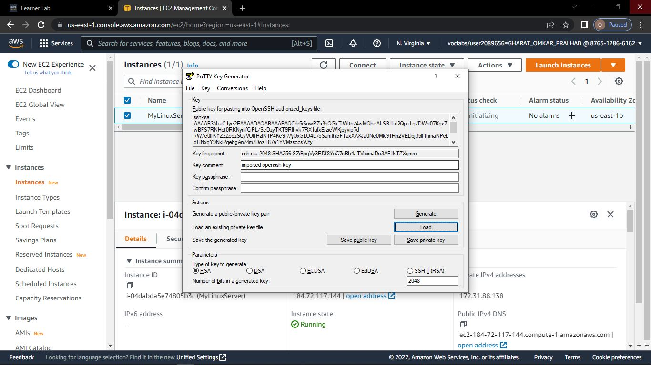



**Step-11: Give any name to the file🡪Click on Save**

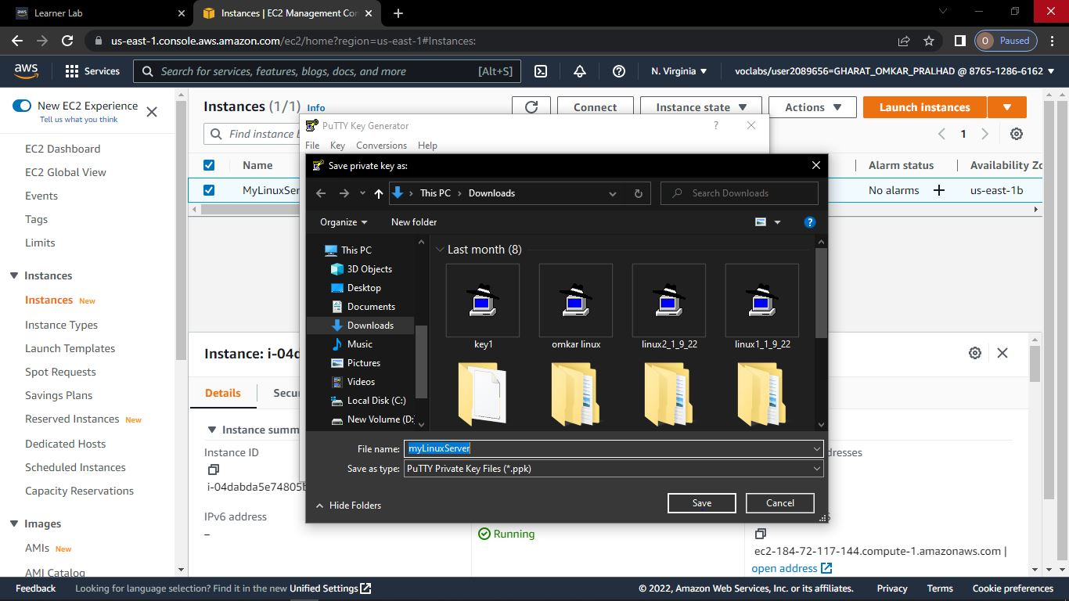

**Step-12: Open Putty 🡪Paste the IP address**

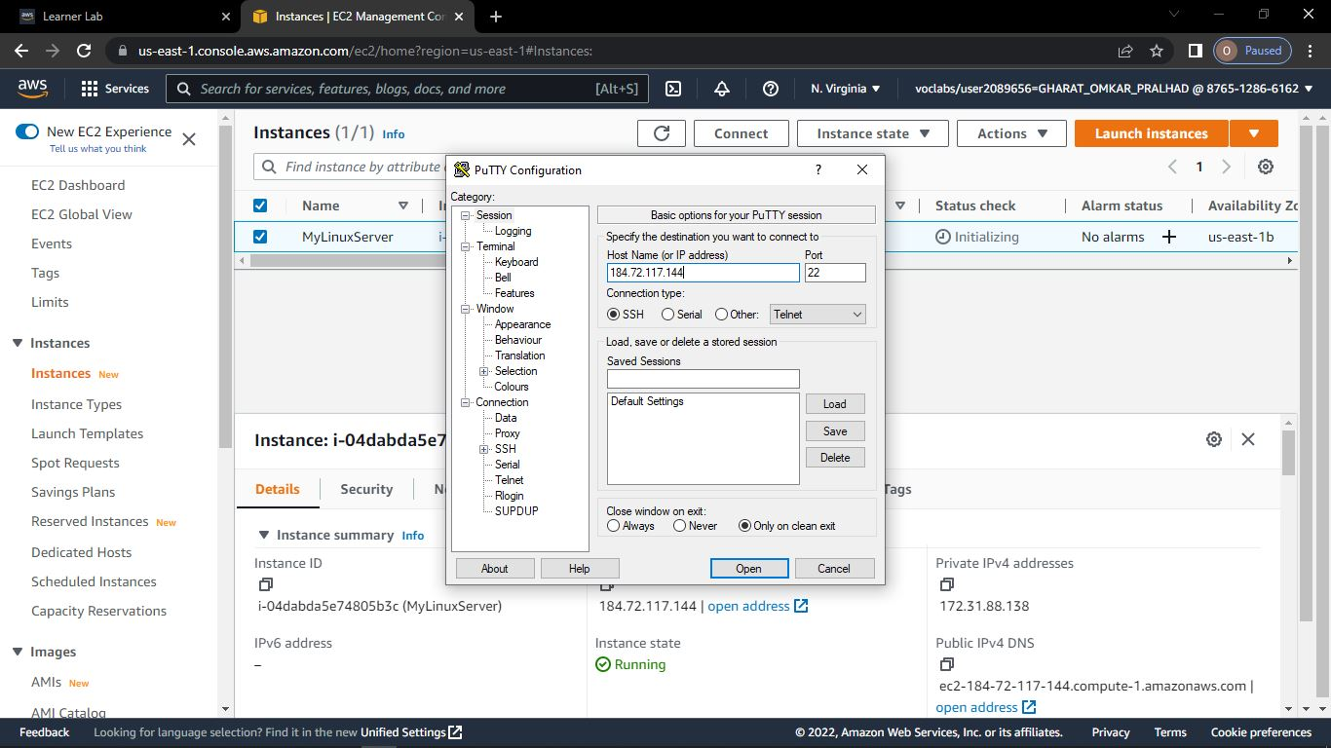



**Step-13: Go to SSH🡪Choose Auth**

**->Browse the newly created file**

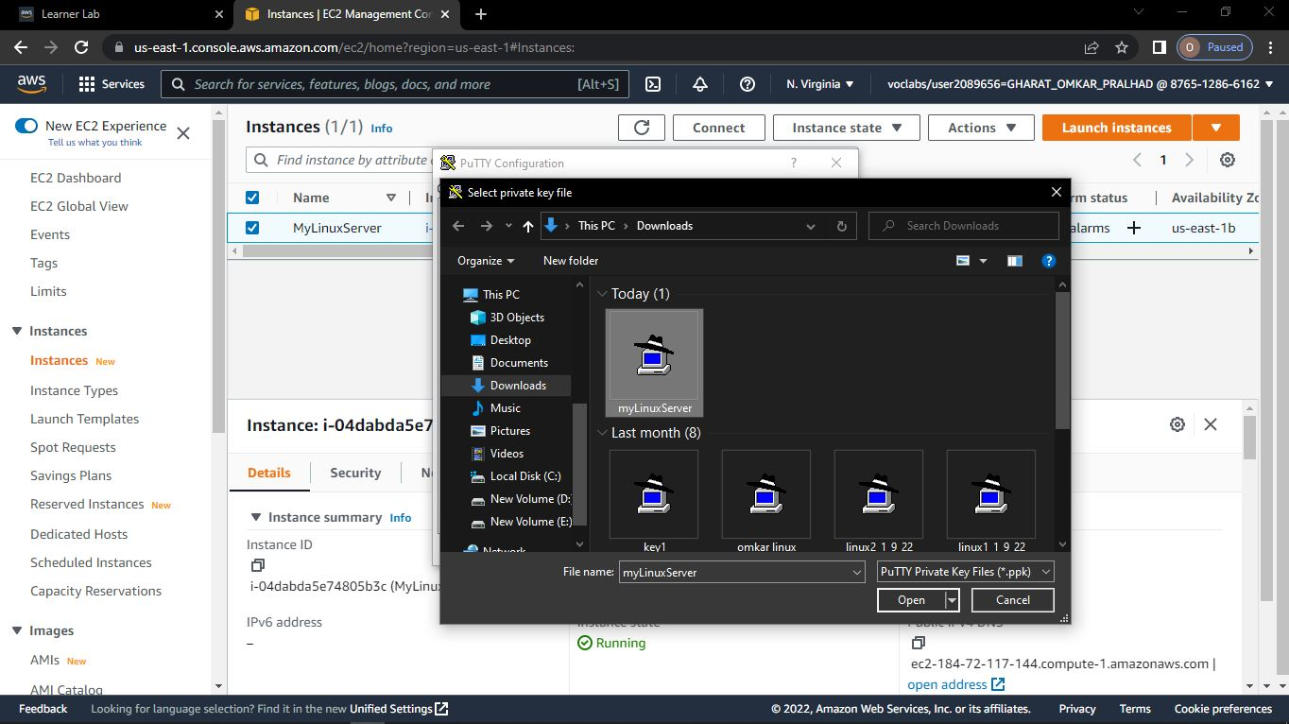

**Step-14: Now you will get access to linux server.**

